To turn our file in to the repository we must initialize the git with the command “git init”.

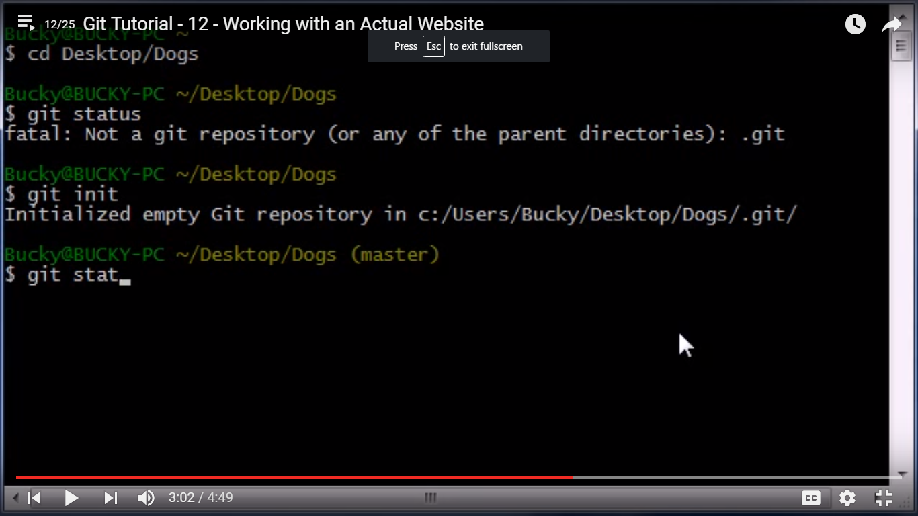

After initialization we need to add those files to the git with the command “git add . ”

Now we have to add to the stagig area with commit syn :git commit -m “commiting “

Instead of adding to the repository from our working copy,we can directly go to the staging area in

Short cut with the command “git commit –am “shortcut for commit with out adding”

L

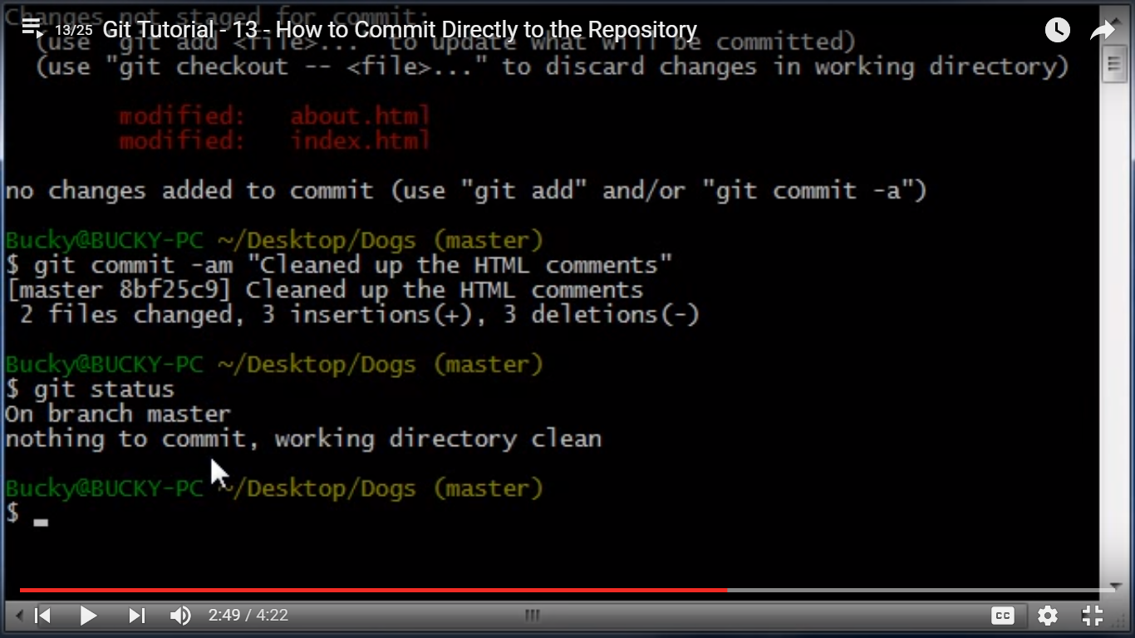

But it is only use ful in some situations bcoz its gonna grab everything in our files and this is only helpful

Whenever we r editing or modifying files.(very simple edits)do not use for rename or move.

Checkout( : “ means take something from your repository and make it as working copy.”

Git checkout -- <file.txt>(undo changes of the file)

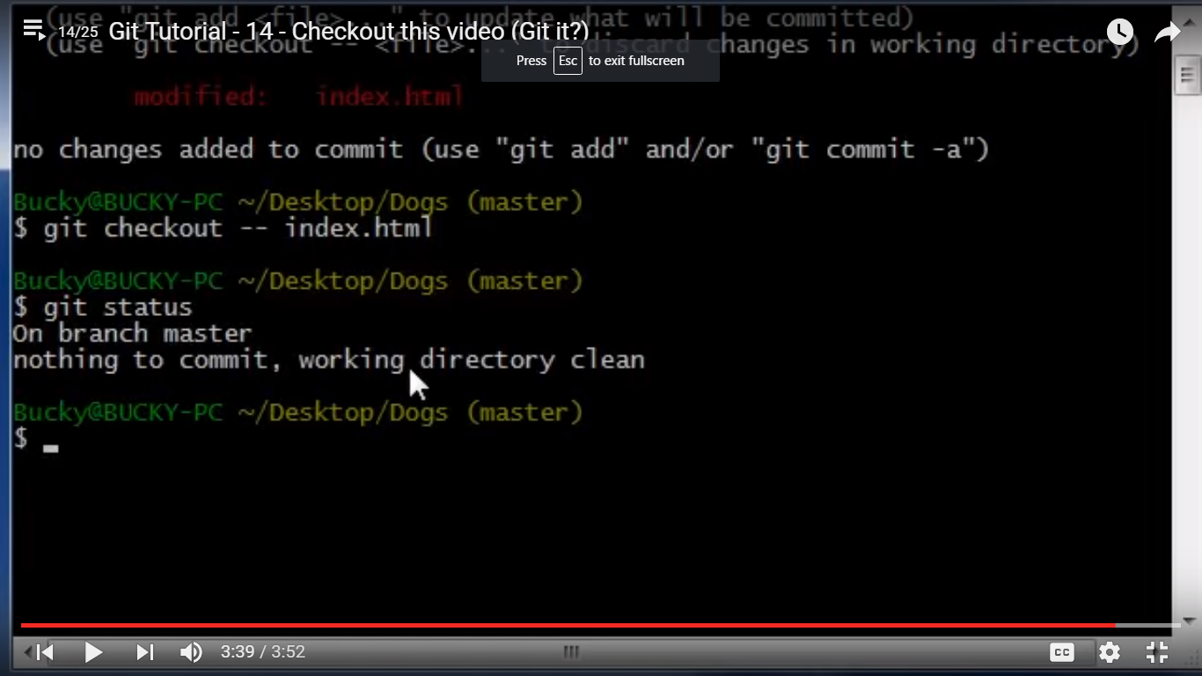

If we want the file remove from the staging area (unstaging) the command wil be:

Git reset HEAD <filename>

To get older versions from the repository :

>git log(we can see commit reference numbers)

Git checkout “commit refrnce number” -- <filename>

Github : to give reference nick name to our public repository url :

” git remote add <nickname> repository url”

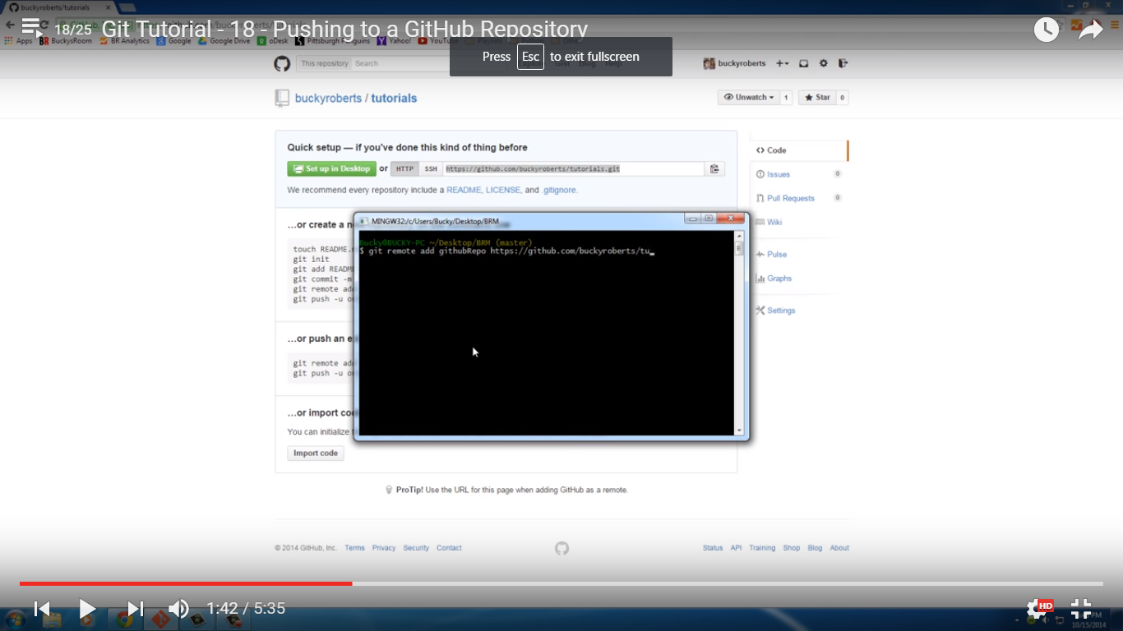

To check our reference name: > git remote